Digital Banking

Cadet Bank makes it easy to manage your money without visiting a branch or ATM.

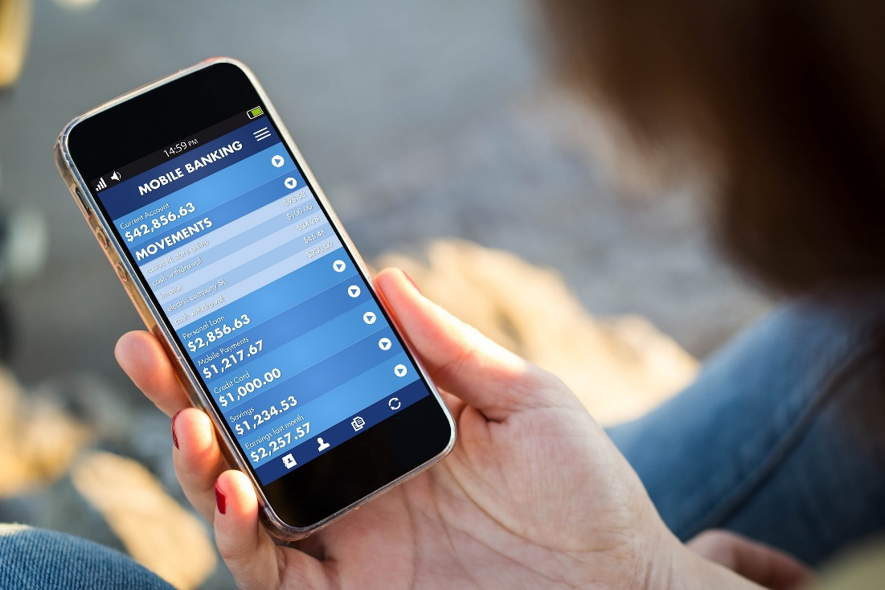

# Online Banking

Visit the Cadet Bank online banking portal to access your accounts, transfer funds, pay bills, and reorder checks. Sign up for instant alerts to notify you when your account balance is getting low. The online banking service is free to Cadet Bank customers and offers the following features:

* all-day access  
  Track balances and transactions on your checking, savings, money market, and credit card accounts any time of the day or night.
* account alerts  
  Receive email notifications when an account balance falls below a specified minimum and when a transaction on your account might be fraudulent.
* online bill pay  
  Send funds to cover recurring or one-time bill payments.
* paper-free statements  
  Access electronic copies of account statements and tax documents to eliminate paper waste.

# Mobile Banking

Manage your money on the go with Cadet Bank’s mobile banking services. Download the Cadet Bank app to your mobile device, and then check balances, pay bills, deposit checks, and more quickly and safely. The Cadet Bank app offers the following features:

* easy sign-in options  
  Forget your password? No problem. The Cadet Bank mobile app lets you securely sign in to your accounts in any of the following ways:
* Touch ID
* Smile ID
* Passcode
* Device registration
* epayments  
  Transfer money to another account, person, organization, or financial institution. 
  + Transfer to and from your Cadet Bank accounts, including credit card accounts.
  + Send money to people using their email address or mobile number.
  + Use automatic bill pay to make payments for one-time or recurring bills.
  + text banking  
    Send a text message to Cadet Bank to request your account balance or recent transaction history.

# Sign Up

Online Banking

Go to cadet.cengage.com.

Click the Sign Up link and set up your credentials.

Follow the prompts to start banking.

Mobile Banking

Download the Cadet Bank app from your device’s app store.

Click the First Time User link and set up your credentials.

Follow the prompts to start banking.

The next time you want to use Cadet Bank’s digital banking services, open the app or go to cadet.cengage.com. Sign in to access your accounts.

# Questions?

For quick answers to any of your digital banking questions, please contact us in one of the following ways:

* Text message  
  Send your questions to (608) 555-2200.
* Phone  
  Call (608) 555-2259.
* Website  
  Visit the Cadet Bank FAQs webpage at cadet.cengage.com.
* Email  
  Send your questions to info@cadet.cengage.com.